4-H EXPO—Explore, Innovate, Inquire, Create
Please select from one of the following dates:

Monday, January 15, 7:00pm (Communication Arts Festival)
Wayne Bartlets Middle School (Registration Due: 1/4/18)

Saturday, April 7, 9:30 – 11:00am (Foods Revue)
Portage Public Library (Registration Due: 3/26/18)

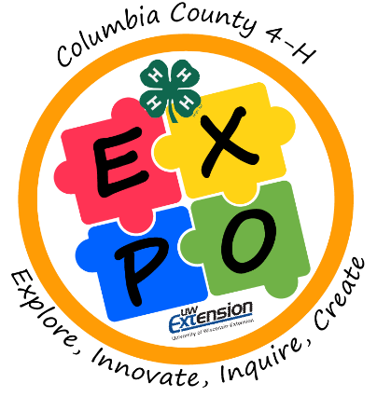
Name: Grade:
4-H Club:
Phone: ( ) -
Email:
Address:
City: ST: WI Zip:
Any special accommodations required? Yes___ No___
If yes, please describe:
Title of Exhibit:
Type of Exhibit (what is it?)**:
Brief Description of Exhibit (i.e. materials used, questions answered, special features, why did you pick this topic, etc.):
4-H Project Area(s) that the Exhibit is related to:
Outlet Needed: Yes*___ No___
*Participants are required to bring their own extension cords if they need an outlet.
**Participants are allotted a card table sized area to display their finished exhibit. Additional decorations may be used as long as the size does not exceed a card table display.

Return to:
Jennifer Evans, UW-Extension,
112 E. Edgewater Street, Room 212, Portage, WI 53901

